

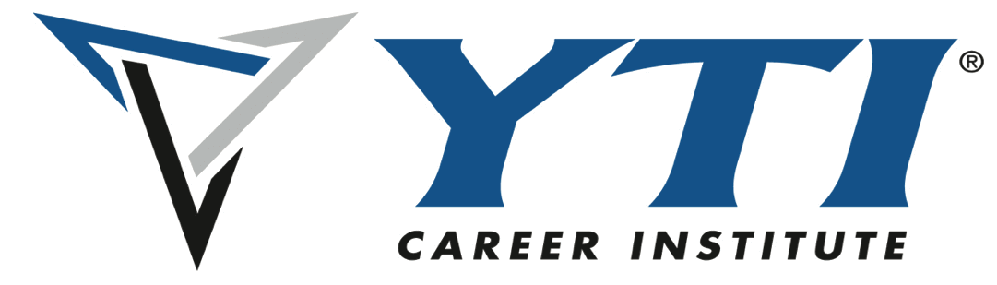

**For Immediate Release:**

**Contact: Desiree Morris**

**desiree.morris@yti.edu**

**717.654.1793**

**Porter and Chester Institute and YTI Career Institute Award Over 1,000 Imagine America Scholarships in 2024**

**March 11th 2024** – Porter and Chester Institute (PCI) and YTI Career Institute (YTI) are proud to announce their continued commitment to student affordability, access and success through the Imagine America Foundation (IAF) Scholarship Program. In 2024, PCI awarded 857 Imagine America Scholarships and Awards, while YTI awarded 176—helping a total of 1,033 students pursue their career training and education.

Each year, the Imagine America Foundation provides financial support to students seeking hands-on, career-focused education. The scholarships awarded by PCI and YTI help students across a variety of skilled trades, healthcare, computers and other technical programs, reinforcing both institutions' dedication to workforce development and career readiness.

"We are honored to support over a thousand students in their journey to build job ready, tangible skills moving towards a rewarding career," said [Jim Bologa, President and CEO. "These scholarships not only provide financial assistance but also encourage students to pursue their professional goals with confidence."

PCI and YTI remain steadfast in their mission to provide high-quality education and training to meet the growing demand for skilled professionals in the transportation, healthcare, construction, information technology and hospitality industries. Through partnerships like the Imagine America Foundation, they continue to make education more accessible and empower students to succeed in their chosen fields.

For more information about the Imagine America Foundation and the programs at PCI and YTI, visit www.porterchester.edu and www.yti.edu.

**About Porter and Chester Institute:** Porter and Chester Institute (PCI), a private, post-secondary technical institution with seven campuses throughout Connecticut and Massachusetts, featuring twelve different career programs, supports committed students in achieving the technical and professional skills essential for their chosen career through industry- modeled, student-centered education and training. For more information, please visit PCI at [www.PorterChester.edu](http://www.PorterChester.edu/) or call (800) 870-6789**.**

**About YTI Career Institute:** YTI is a private, post-secondary technical institution of higher education serving south-central Pennsylvania at the York, Lancaster, and Altoona campuses. YTI Career Institute offers career training in the [computer](https://yti.edu/programs/computer-programs), [culinary arts](https://yti.edu/paschoolofculinaryarts), [healthcare](https://yti.edu/programs/medical-programs) and skilled [trades](http://trades) fields. For more information, visit [www.yti.edu](http://www.yti.edu).